

ATTENDANCE POLICY

- Introduction

At Bishop Bridgeman we take our obligation to provide all children on roll with their full educational entitlement very seriously. We understand that if children are to make the most of this entitlement, they must be present in school for the maximum time possible.

It is the school's intention therefore to monitor carefully the attendance of its pupils to ensure that no child misses out unnecessarily on their entitlement in line with the school vision “love God, love yourself, love your neighbour” Luke 10:27.

Our unwavering commitment to attendance centres around child-centric actions, evidence-informed practices, and a shared understanding of everyone's roles and collective responsibilities to promote exceptional attendance

- Aims

We are committed to meeting our obligation with regards to school attendance through our whole-school culture and ethos that values good attendance, including:

- Promoting good attendance
- Reducing absence, including persistent and severe absence
- Ensuring every pupil has access to the full-time education to which they are entitled
- Acting early to address patterns of absence
- Building strong relationships with families to ensure pupils have the support in place to attend school
We will also promote and support punctuality in attending lessons.

- Roles and Responsibilities

We believe that the promotion and attainment of a good attendance record involves developing positive attitudes amongst children by teachers, parents, the Early Intervention Team and the Governing Body.

The success of the policy will depend on all parties working together, but the school wants to work especially closely with the parents in this regard.

3.1 Governors
Governors are responsible for:

- Having high expectations for pupil attendance and promoting the importance of this across the school’s ethos and policies.
- Ensuring that school leaders fulfil expectations and statutory duties.
- Taking a strategic approach to attendance. They consider attendance as a key performance indicator and monitor and challenge trends and patterns in attendance data.
- Reviewing attendance data regularly to identify and challenge trends and help school leaders focus improvement efforts on the individual pupils or cohorts who need it most.
- Ensuring that school staff, including teachers and support staff, receive adequate training related to attendance.
The governor responsible for attendance is Cllr John Walsh.
3.2 Headteacher and attendance lead
The role of the headteacher and attendance lead in improving children's attendance in school is critical in ensuring that students attend school regularly and achieve their educational potential. They will have multifaceted roles that encompass various responsibilities and strategies aimed at enhancing attendance rates.At Bishop Bridgeman, the headteacher is Mr. Mike Lonsdale and the designated attendance leader is Mr. Chris Finn.
The headteacher and attendance lead will work together to:
- Work closely with school leadership and staff to develop and implement effective attendance policies and procedures.
- Collect and analyse attendance data to identify trends and patterns. They use this information to pinpoint areas of concern, such as high levels of persistent absence, frequent lateness, or particular year groups or demographic groups with attendance challenges.
- Recognise that early intervention is crucial and identify children at risk of poor attendance. They collaborate with teachers, parents, and support staff to address attendance issues as soon as they arise.
- Work closely with parents and carers to build positive relationships and engage them in improving their child's attendance. They may conduct home visits, organise meetings, and provide guidance on strategies to promote regular attendance.
- Offer mentoring or coaching to children with attendance problems. They help children understand the importance of attending school regularly and provide strategies for overcoming barriers.
- Connect families with resources and services that can help alleviate attendance-related challenges, such as housing support, counselling, or healthcare services.
- Continuously monitor attendance records and report attendance data to school leadership, governing bodies, and local authorities as required. They ensure that accurate records are maintained.
- Design and implement interventions and incentives to motivate children to attend school. This may include recognition for attendance, recognition programmes, or targeted interventions for specific groups of students.
- Provide training to school staff on effective attendance monitoring, reporting, and intervention strategies. They ensure that all staff members understand their roles in promoting attendance.
- Be knowledgeable about legal requirements related to attendance, including regulations governing authorised and unauthorised absences. They ensure the school complies with these regulations.
- Be vigilant for safeguarding concerns related to attendance. They recognise signs of neglect or abuse and report them to designated safeguarding officers or authorities as necessary.
- Collaborate with community organisations, social services, and local authorities to address attendance issues within the broader community context.
- Regularly evaluate the effectiveness of attendance strategies and interventions. They adapt their approaches based on data and feedback to achieve sustained improvements in attendance rates.
- Contribute to creating a school culture where attendance is valued, and students feel motivated and supported to attend regularly.
The headteacher and attendance lead can be contacted via 01204 333466 and office@bishop-bridgeman.bolton.sch.uk
3.4 Pastoral Manager
The school attendance officer is responsible for:
- Monitoring and analysing attendance data (see section 6)
- Benchmarking attendance data to identify areas of focus for improvement
- Providing regular attendance reports to school staff and reporting concerns about attendance to the designated senior leader responsible for attendance and the headteacher
- Working with education welfare officers to tackle persistent absence
- Advising the headteacher when to issue fixed-penalty notices.

3.5 Teachers and teaching assistants
- Class teachers are responsible for recording attendance on a daily basis, using the correct codes, and submitting this information to the school office before the time of the register closing.
- Arranging calls and meetings with parents to discuss attendance issues
- Having an oversight of data analysis for the children in their class using the school attendance tracker and keeping it continually updated.
- Take immediate action when a child is absent without prior notification or a valid reason. This may involve contacting the school's attendance officer or designated staff member to report the absence.
- Support early intervention through identifying patterns of poor attendance or lateness and intervene early to address any underlying issues. This may include communicating with the student, their parents or carers and relevant support services.
- Maintain open lines of communication with parents or carers regarding attendance. They should inform parents of any concerns about a child's attendance or punctuality.
- Provide academic and emotional support to children who may be experiencing attendance challenges. Identifying the root causes and addressing them proactively can help improve attendance.
- Set clear expectations for attendance and punctuality in their classrooms. This includes communicating the importance of regular attendance for learning and academic progress.
- Create a positive and welcoming classroom environment where students feel motivated and engaged. A supportive atmosphere can encourage attendance.
- Be alert to potential barriers to attendance, such as bullying, health issues, or family problems. Identifying these barriers and reporting them to school staff can lead to effective interventions.
- Adhere to and implement the school's attendance policies and procedures.
- Collaborate with other school staff, such as attendance officers, counsellors, and administrators, is essential for
- addressing attendance concerns effectively. Teamwork ensures a coordinated approach to supporting students.
- Implement strategies to reinforce positive behaviour related to attendance, such as recognising attendance and
- punctuality.
- Be aware of safeguarding protocols and report any concerns related to a child's safety or well-being promptly to
- the appropriate school staff.
- Engage in professional development around addressing attendance.
- Serve as role models by demonstrating punctuality and a commitment to their own professional responsibilities.

At Bishop Bridgeman, we also recognise the importance that teaching assistants can play in promoting good attendance. We expect teaching assistants to support teachers, and the school, with the expectations outlined above.

3.6 School administrators
School administrators will:

- Take calls from parents about absence on a day-to-day basis and record it on the school system
- Provide an analysis of attendance data.
3.7 Parents/Carers
Parents play a crucial role in supporting attendance in our school. Their involvement and commitment to their child's education can have a significant impact on attendance rates.
At Bishop Bridgeman parents are expected to:
Establish a daily routine that includes regular school attendance. Consistency in waking up, getting ready for school, and arriving on time helps children develop good attendance habits.
  - Inform the school promptly if your child is going to be absent due to illness or other reasons. This helps the school keep accurate attendance records.
  - Promote good health practices, including proper nutrition, regular exercise, and adequate sleep. A healthy child is less likely to miss school due to illness.
  - Encourage a positive attitude towards education. Discuss the value of school and the opportunities it provides for the child's future.
  - Clearly communicate your expectations about attendance to your child. Emphasize the importance of attending school regularly and on time.
  - Support your child's learning by showing interest in their homework and school assignments. Provide a quiet, conducive space for homework.
  - Participate in parent-teacher consultations and evenings. These provide an opportunity to discuss your child's progress and address any attendance or academic concerns.
  - Keep track of your child's progress and attendance. Be aware of any sudden changes in attendance patterns that may signal underlying issues.
  - Address any concerns through communicating with the school to ensure a safe and supportive environment.
  - Encourage curiosity and a love for learning. Explore educational activities and resources outside of school to spark your child's interest in different subjects.
  - Demonstrate the importance of commitment and responsibility by being punctual and dependable in your own daily activities.
  - Stay informed about school policies and attendance guidelines. Understand the consequences of excessive absenteeism.
  - Seek support if needed. If your child is facing challenges that affect attendance, such as health issues or academic struggles, seek support from the school, healthcare professionals, or relevant agencies.
  - Encourage your child to form positive relationships with peers. Friendships can make school a more enjoyable and supportive environment.
  - Celebrate your child's achievements and milestones at school. Recognise their efforts and successes to boost their self-esteem and motivation.
  - Work collaboratively with the school to address any attendance issues. Explore support services or interventions if necessary.
3.8. Pupils
Pupils also play a significant role in attending school regularly and ensuring their educational success. Here are some key roles and responsibilities that children can take on to support their attendance in school:
  - Show a positive attitude and a commitment towards school and learning.
  - Arrive at school on time each day.
  - Take responsibility for their own education by completing homework and assignments on time.
  - Build positive relationships with peers which can help make school a more welcoming place.
  - Actively participate in classroom activities.
  - Follow safety guidelines and rules at school to ensure their well-being.
  - Respect teachers and school staff to foster a positive school environment.
  - Maintain a healthy lifestyle through proper nutrition, regular exercise and adequate sleep to help contribute to overall well-being, which can reduce the risk of illness-related absences.
  - Develop an awareness of the importance of attendance and its impact on their education.
  - Seek support if a child is facing challenges in school that affect attendance.

Legislation and guidance
This policy meets the requirements of the working together to improve school attendance from the Department for Education (DfE) which came into effect from 19th August 2024.This attendance policy operates within the framework of statutory attendance regulations outlined in the Education (Pupil Registration) (England) Regulations 2006 and subsequent amendments.

Bishop Bridgeman adheres to the following key attendance acts in the UK:
  - Education Act 1996
  - Education (Pupil Registration) Regulations 2006
  - Education (Penalty Notices) (England) (Amendment) Regulations 2024
  - Education (Pupil Registration) (England) (Amendment) Regulations 2013
  - School Attendance Code of Practice
  - Child Employment Legislation
  - Children Missing Education (CME) Statutory Guidance
  - Section 19 of the Education Act 1996 (England and Wales)

- Recording Attendance
5.1 Attendance Registers
- Registers should be sent to the admin team as soon as they are completed after 8.50 and 1.15.
- Children are marked present with /
- Children are marked absent with N
- Children who are absent for any reason will have the correct attendance code entered in by the School Administration staff.
- Children who arrive late after 9.20am with an authorised reason will be regarded as present for statistical purposes but will have the correct attendance code shown against their name.
- Children who arrive late after 9.20 a.m without an authorised reason will be regarded as present for statistical purposes but will have the mark N shown against their name.
- Children arriving late must enter the school building via the Main Entrance, and must give their name to the School Administration Staff before going to class
- The School Administration Staff will amend registers appropriately for any child arriving late.
5.2 Contact Details
- Parents are required to phone school 01204 333466 to report an unexpected absence which will be recorded and passed on to the class teacher.
- For support regarding attendance please contact Mr. Finn 01204333466.
5.3 Planned absence
Attending a medical or dental appointment will be counted as authorised as long as the pupil’s parent/carer notifies the school in advance of the appointment by contacting the school office on 01204 333466. However, we encourage parents/carers to make medical
and dental appointments out of school hours where possible. Where this is not possible, the pupil should be out of school for the minimum amount of time necessary.

5.4 Unplanned absence

It is the responsibility of the pupil’s parent/carer to notify the school of the reason for the absence on the first day of an unplanned absence by 8:55am or as soon as practically possible by calling the school office on 01204 333466.

We will mark absence due to physical or mental illness as authorised, unless the school has a genuine concern about the authenticity of the illness. Where there are doubts about the authenticity of the illness, the school will ask for medical evidence, such as a doctor’s note, prescription, appointment card or other appropriate form of evidence. We will not ask for medical evidence unnecessarily. If the school is not satisfied about the authenticity of the illness, the absence will be recorded as unauthorised and parents will be notified of this in advance.
5.5 Lateness and punctuality
A pupil who arrives late:
- Before the register has closed will be marked as late, using the appropriate code
- After the register has closed will be marked as absent, using the appropriate code.
- Parents/Carers will be asked to provide a reason for arriving late.
5.6 Following up unexplained absence
Where any pupil we expect to attend school does not attend, or stops attending, without reason, the school will:
- Call the pupil’s parent/carer on the morning of the first day of unexplained absence to ascertain the reason. If the school cannot reach any of the pupil’s emergency contacts, the school may conduct a home visit.
- Identify whether the absence is approved or not
- Identify the correct attendance code to use and input it as soon as the reason for absence is ascertained.
- Call the parent/carer on each day that the absence continues without explanation to ensure proper safeguarding action is taken where necessary. If absence continues, the school will consider involving an education welfare officer.

- Authorised and Unauthorised Absence

  - Approval for term-time absence

The headteacher will allow pupils to be absent from the school site for certain educational activities, or to attend other schools or settings. The headteacher will only grant a leave of absence to a pupil during term time if the request meets the specific circumstances set out in the 2024 school attendance regulations. These circumstances are:

- Attending an interview
- Taking part in a regulated performance, or regulated employment abroad
- Study leave
- A temporary, time-limited part-time timetable
- Exceptional circumstances

A leave of absence is granted at the headteacher’s discretion, including the length of time the pupil is authorised to be absent for. We define ‘exceptional circumstances’ as one off events that are unavoidable, examples may include the death of a close relative, attendance at a funeral or a housing crisis that prevents attendance.

Leave of absence will not be granted for a pupil to take part in protest activity during school hours.

As a leave of absence will only be granted in exceptional circumstances, it is unlikely a leave of absence will be granted for the purposes of a family holiday.

The school considers each application for term-time absence individually, taking into account the specific facts, circumstances and relevant background context behind the request.

Any request for planned term-time absence should be submitted as soon as it is anticipated and, where possible, at least two weeks before the absence. This should be put in writing for the attention of the headteacher. The headteacher may require evidence to support any request for leave of absence.

Other valid reasons for authorised absence include (but are not limited to):

- Illness (including mental-health illness) and medical/dental appointments
- Religious observance – where the day is exclusively set apart for religious observance by the religious body to which the pupil’s parent(s) belong(s). If necessary, the school will seek advice from the parent’s religious body to confirm whether the day is set apart
- Parent(s) travelling for occupational purposes – this covers Roma, English and Welsh gypsies, Irish and Scottish travellers, showmen (fairground people) and circus people, bargees (occupational boat dwellers) and new travellers. Absence may be authorised only when a traveller family is known to be travelling for occupational purposes and has agreed this with the school, but it is not known whether the pupil is attending educational provision
- If the pupil is currently suspended or excluded from school (and no alternative provision has been made)
Other reasons the school may allow a pupil to be absent from the school site, which are not classified as absences, include (but are not limited to):

- Attending an offsite approved educational activity, sporting activity or visit or trip arranged by the school
- Attending another school at which the pupil is also registered (dual registration)
- Attending provision arranged by the local authority
- Attending work experience
- If there is any other unavoidable cause for the pupil not to attend school, such as disruption to travel caused by an emergency, a lack of access arrangements, or because the school premises are closed

6.2 Unauthorised Absence

School will mark pupil absence as unauthorised for the following (but not limited to) reasons:

- Parents keeping children off school unnecessarily or without reason.
- Truancy before or during the school day.
- Absences which have never been properly explained.
- Absences for illness where there are doubts about the authenticity of the illness.
- Arrival at school after the register has closed.
- Absence due to shopping, looking after other children or birthdays.
- Absence due to day trips and holidays in term-time which have not been agreed.

- Leaving school for no reason during the day.

6.3 Legal sanctions
Our school will make use of the full range of potential sanctions – including, but not limited to, those listed below – to tackle poor attendance. Decisions will be made on an individual, case-by-case basis.

6.4 Penalty notices
The headteacher (or someone authorised by them), local authority or the police can fine parents for the unauthorised absence of their child from school, where the child is of compulsory school age, by issuing a penalty notice.

If the school issues a penalty notice, it will check with the local authority before doing so, and send it a copy of any penalty notice issued.

Before issuing a penalty notice, the school will consider the individual case, including:

- Whether the national threshold for considering a penalty notice has been met (10 sessions of unauthorised absence in a rolling period of 10 school weeks)
- Whether a penalty notice is the best available tool to improve attendance for that pupil
- Whether further support, a notice to improve or another legal intervention would be a more appropriate solution
- Whether any obligations that the school has under the Equality Act 2010 make issuing a penalty notice inappropriate

Each parent who is liable for the pupil’s offence(s) can be issued with a penalty notice, but this will usually only be the parent/parents who allowed the absence.

The payment must be made directly to the local authority, regardless of who issues the notice. If the payment has not been made after 28 days, the local authority can decide whether to prosecute or withdraw the notice.

If issued with a first penalty notice, the parent must pay £80 within 21 days, or £160 within 28 days.

If a second penalty notice is issued to the same parent in respect of the same pupil, the parent must pay £160 if paid within 28 days.

A third penalty notice cannot be issued to the same parent in respect of the same child within 3 years of the date of the issue of the first penalty notice. In a case where the national threshold is met for a third time within those 3 years, alternative action will be taken instead.
In these cases, the parent must pay £60 within 21 days, or £120.

A penalty notice may also be issued where parents allow their child to be present in a public place during school hours without reasonable justification, during the first 5 days of a suspension or exclusion (where the school has notified the parents that the pupil must not be present in a public place on that day). These penalty notices are not included in the National Framework, not subject to the same considerations about support being provided, and do not count towards the limit as part of the escalation process.

In these cases, the parent must pay £60 within 21 days, or £120.

6.5 Notices to improve
If the national threshold has been met and support is appropriate, but parents do not engage with offers of support, the school may offer a notice to improve to give parents a final chance to engage with support.

Notices to improve will be issued in line with processes set out in the local code of conduct for the local authority area in which the pupil attends school.

They will include:

- Details of the pupil’s attendance record and of the offences.
- The benefits of regular attendance and the duty of parents under section 7 of the Education Act 1996.
- Details of the support provided so far.
- Opportunities for further support, or to access previously provided support that was not engaged with.
- A clear warning that a penalty notice may be issued if attendance doesn’t improve within the improvement period, along with details of what sufficient improvement looks like, which will be decided on a case-by-case basis.
- A clear timeframe of between 3 and 6 weeks for the improvement period.
- The grounds on which a penalty notice may be issued before the end of the improvement period.
If voluntary support or attendance contracts are unsuccessful, an Education Supervision Order (ESO) can provide formal legal intervention without prosecution. Before proceeding with an ESO, the school and local authority should exhaust voluntary support options and ensure the order would benefit the pupil and parent.

Persistent non-compliance with an ESO can lead to prosecution in the Magistrates Court by the local authority. Upon conviction, parents may face fines of up to £1,000. Local authorities have the power to prosecute parents for various offences related to attendance: Failure to comply with a school attendance order may result in fines of up to £1,000. Failure to secure regular attendance at school or alternative provision may lead to fines of up to £2,500 and/or imprisonment. Persistent non-compliance with an Education Supervision Order may result in fines of up to £1,000.

- Attendance Monitoring

The school will:

- Monitor absence every day and school administrators will contact parents/carers if no reason for absence has been given.
- Monitor whole school attendance every week to identify the classes/pupil groups where attendance is strong or of concern
- Monitor whole school attendance and absence data every half term to identify groups of children whose absence may be a cause for concern
- Analyse data regularly to identify individuals and groups or pupils that need additional attendance support and to identify emerging patterns of attendance and absence which may require targeted support.
- School leaders facilitate time dedicated time every week to allow class teachers to analyse their individual class attendance data which allows them to facilitate discussions with pupils and families.
- Monitor attendance and absence data half-termly, termly and yearly across the school and at an individual pupil level.

Pupil-level absence data will be collected each term and published at national and local authority level through the DfE's school absence national statistics releases. The underlying school-level absence data is published alongside the national statistics. The school will compare attendance data to the national average, and share this with the governing board, and when requested, with Trustees.

School also makes use of Fischer Family Trust Attendance tracker and Insight Tracking attendance tracker to support analysis of attendance.

7.1 Weekly Totals

The school administration staff are responsible for monitoring absence and updating the electronic registration.

7.2 Monthly/Termly/Annual Totals

The school administration staff will complete these figures and will also complete any returns to the L.A. concerning attendance.

7.3 Weekly Percentages

The attendance lead will convert weekly totals into a percentage figure so that they can be used for the school’s reward systems.

7.4 Telephone Absence Messages

The school administration staff will keep a record of all messages received concerning absence and will also notify class teachers by recording the call on CPOMS and placing a note on the register.
- Strategies for Promoting Attendance
At Bishop Bridgeman, we have used the Department for Education's (DFE) "Working Together to Improve School Attendance" statutory paper 2024 to create a set of strategies to promote and increase attendance.
We use our attendance ladder as a basis for tackling poor attendance (see appendix 2 for full details).
In the first instance, where attendance concerns are raised, school will offer support to a family and/or pupil through discussions with the class teacher. If parents have concerns about their child’s attendance, they can contact their child’s class teacher or contact the school office to make an appointment with the attendance lead.
School will work closely with parents and pupils where there has been prolonged absence from school (such as illness, recovery from an operation, emotionally school-based avoidance) and the pupil is due to return, or is still unable to attend. Where a pupil has an education health and care (EHC) plan and their attendance falls, or the school becomes aware of barriers to attendance that related to the pupil’s needs, the school will inform the local authority. Situations will be managed on a case by case basis.
Teachers will usually be the first point of contact to discuss concerns with a parent. If concerns are still present after support from the teacher and absence has become persistent, then a formal letter will be sent out. This will be reviewed after three weeks, and if no there are still concerns, a second letter will be sent out.
If it is clear there are still concerns at this stage then the attendance lead will invite parents in to discuss the barriers and create a collaborative attendance plan which is a formal agreement between parents and the school or local authority to address irregular attendance, providing support as an alternative to prosecution. It is not legally binding but serves as a formal route to secure engagement with support when voluntary early help plans have not worked. An attendance contract aims to offer support rather than punishment.
To support the work that school does to develop and maintain a culture of promoting good attendance, we use the following incentives:
- Monthly Attendance ‘Hollywood Bowl’ lottery draws.
- Weekly class attendance recognition.
- Teacher messages and phone calls for recognition of good/improved attendance.
- Thank you cards to be sent home for improved attendance.
- Termly certificates for 100% attendance (97% + depending on the circumstances of brief absence).
- Reducing persistent and severe absence
Persistent absence is where a pupil misses 10% or more of school, and severe absence is where a pupil misses 50% or more of school. Reducing persistent and severe absence is central to the school’s strategy for improving attendance.
Our strategy for reducing persistent and severe absence includes:
- Follow the steps on the attendance response ladder.
- Consider potential safeguarding issues and, where suspected or present, address them in line with Keeping Children Safe in Education
- Analise and monitor attendance data to find patterns and trends of persistent and severe absence.
- Hold regular meetings with the parents of pupils who the school considers to be vulnerable, or are persistently or severely absent, to:
- Discuss attendance and engagement at school
- Listen, and understand barriers to attendance
- Explain that help is available
- Explain the potential consequences of, and sanctions for, persistent and severe absence
- Review and existing actions or interventions
- Provide access to wider support services to remove the barriers to attendance.
- Class teachers will update the class attendance tracker weekly.
- Class teachers will discuss attendance concerns with parents following the steps of the attendance response ladder.
- Attendance lead will hold collaborative meetings with parents at relevant points of the process.

13. Monitoring arrangements

This policy will be reviewed as guidance from the local authority or DfE is updated, and as a minimum every two years by the headteacher/attendance lead. At every review, the policy will be approved by the full governing board.

14. Inclusion

At Bishop Bridgeman we apply our policy fairly and consistently we make sure we consider the individual needs of pupils and their families who have specific barriers to attendance.

Prepared by: Chris Finn & Mike Lonsdale

Reviewed: October 2024

Next review date: September 2025

Appendix One – attendance codes

The following codes are taken from the DfE’s guidance on school attendance.
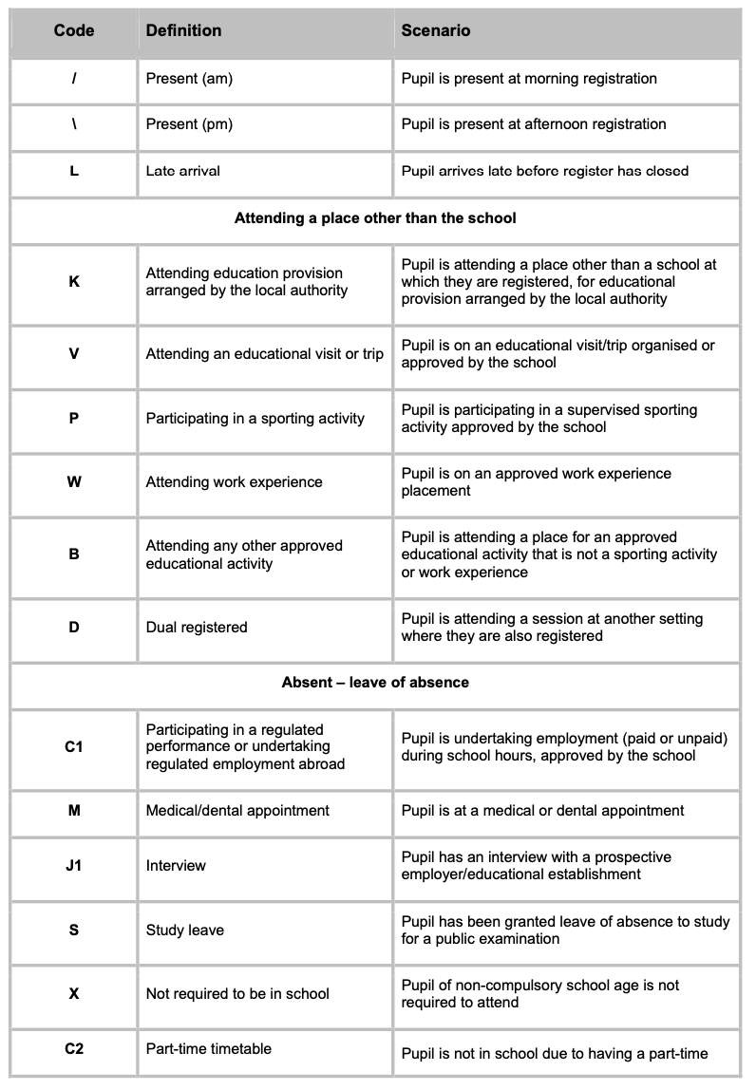

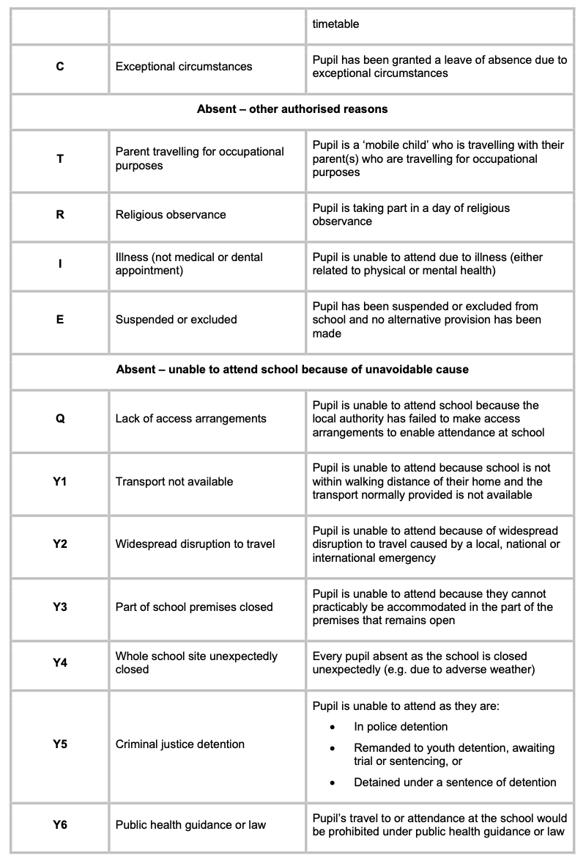

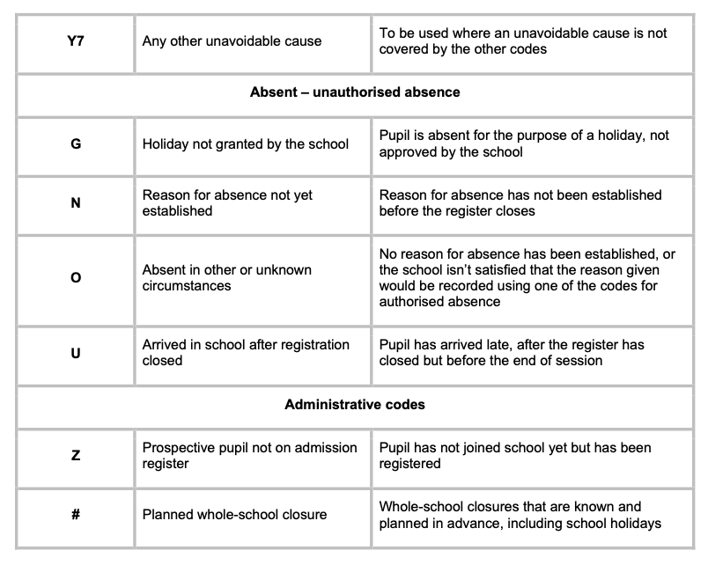

Appendix Two
Attendance Response Ladder

Start of Year

Re-establishing the importance of attendance as a priority for our school community.
- Trust and school letter sent out to all parents a long with our 'Attendance Matters' leaflet.
- Attendance incentives re-introduced whole school and start on the first week back.
- Emphasis on attendance shared with parents during meet the teacher parent workshops.

Monitoring
Stage 1

Monitoring process begins at the start of the school year.
- Class teachers monitor and record student’s attendance that is below 97% on our attendance tracker.
- Class teachers note any discussions with individual parents/cares to understand any barriers on the tracker.
- Support offered by the class teacher and attendance lead.

Monitoring
Stage 2

If after continuous monitoring and wave one level of support, there is no impact and student’s attendance becomes classified as persistently absent (less that 90%) then formal letter 1 is sent to parents/carer.
- Formal letter offers support and showcases potential future consequences.
- 3-week review by class teacher.

Monitoring
Stage 3

If 3-week monitoring period subsides and attendance is still not improving with persistent absence still a concern, then formal letter 2 is sent to parents/carer.
- Formal letter offers support and showcases potential future consequences.
- Second 3-week review by class teacher.

Formal Stage

If 3-week monitoring period subsides and attendance is still not improving with persistent absence still a concern, then formal letter 3 is sent to parents/carer.
- Formal letter inviting parents into school to meet with attendance lead.
- Discussion of support offered so far and agree a collaborative action plan going forward to help improve attendance.
- Third 3-week review undertaken by attendance lead.

Early help assessment

If 3-week monitoring period subsides and attendance is still not improving with persistent absence still a concern, then begin early help assessment process, may include involvement with other agencies i.e. early intervention, social care, school nurse etc.

Warning

Final step on the ladder, if monitoring and waves of support have not had an impact on improving attendance then official warning letter issued by the headteacher with potential for legal action or risk of losing school place.

